
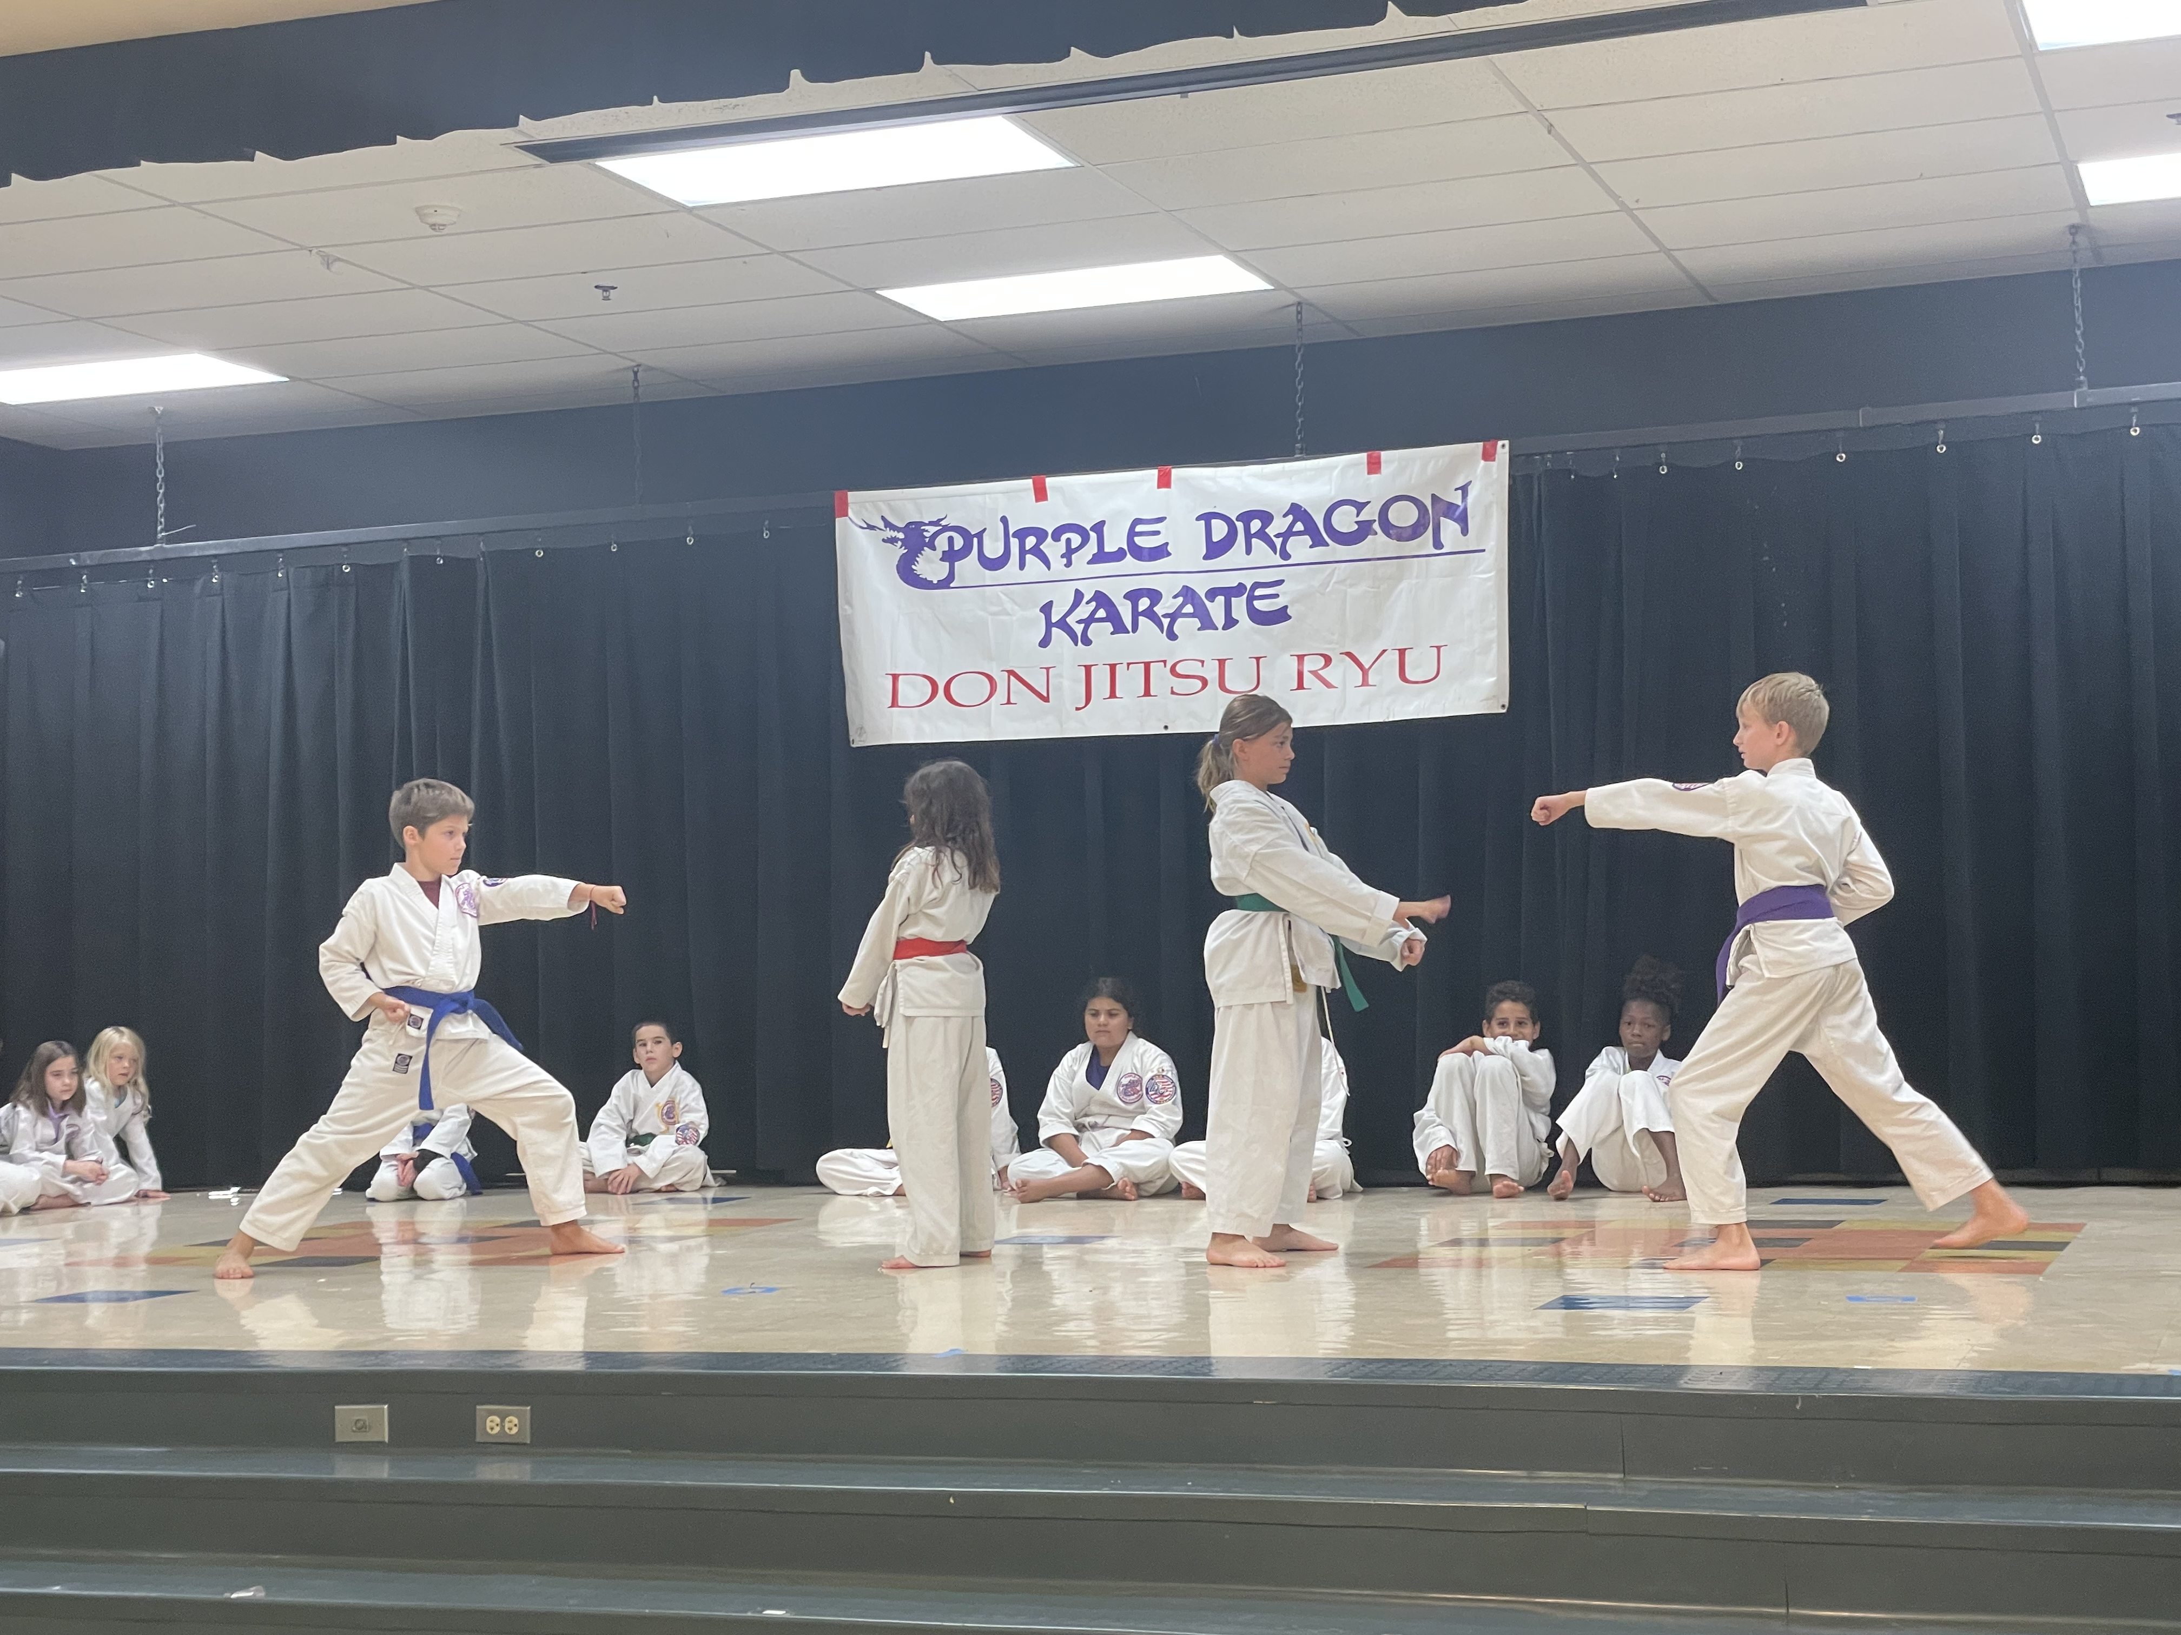
Join our 2025-2026
LSCE Afterschool Karate Program
KARATE
561-307-2516
Opt 1:LSCE Class only Only $100 month Reg $99
Best Option: LSCE Classes plus unlimited extra classes at the Tequesta Dojo $150/month Pickups available Mon & Wed ($75)
Friday's @ 2.15pm – 3.15pm
Classes began in September and will continue till School Closes.
Only 20 spots are available reserve yours today. All grades welcomed
Fun
Focus
Courtesy
Bully Proof
Confidence
Perseverence
Positive Spirit
Our Martial Arts Program has been active at LSCE since 2010, since then some of our LSCE alumni have made it to their black belts, competed locally, Nationally and internationally; You can too. Registration easy for you.....Respectfully Shihan Albert Andrews 7th Dan
Email us @ purpledragonflorida@gmail.com www.purpledragonsoflo.com
Purple Dragon Karate Dojo, 150N US1, Suite 9, Tequesta, Fl,33469
Purple Dragon Karate is not affiliated with or endorsed by the School Board of Palm Beach County or Limestone Creek and the events/ activities hosted by Purple Dragon Karate on Limestone Creek's Premises Pursuant to a lease agreement shall not be construed and being conducted, funded, hosted or sponsored by the school board or Limestone Creek on behalf of Purple Dragon Karate. The School Board and Limestone Creek undertake no responsibility for supervising or monitoring Purple Dragon Karate events/activities and will not be liable for any or all actions of Purple Dragon Karate Progam on Limestone Creek's Premises.

